MACH4METAL

metalworking machinery
Transito 21
6909 DA BABBERICH Netherlands
Tel. +31 (0)316-247123
Fax: +31 (0)316-247956
info@mach4metal.com
www.mach4metal.com

Bank No : 66.52.13.883
IBAN : NL33 INGB 0665 2138 83
BIC : INGBNL2A
www.mach4metal.com

KOIKE ARONSON Plasma cutting
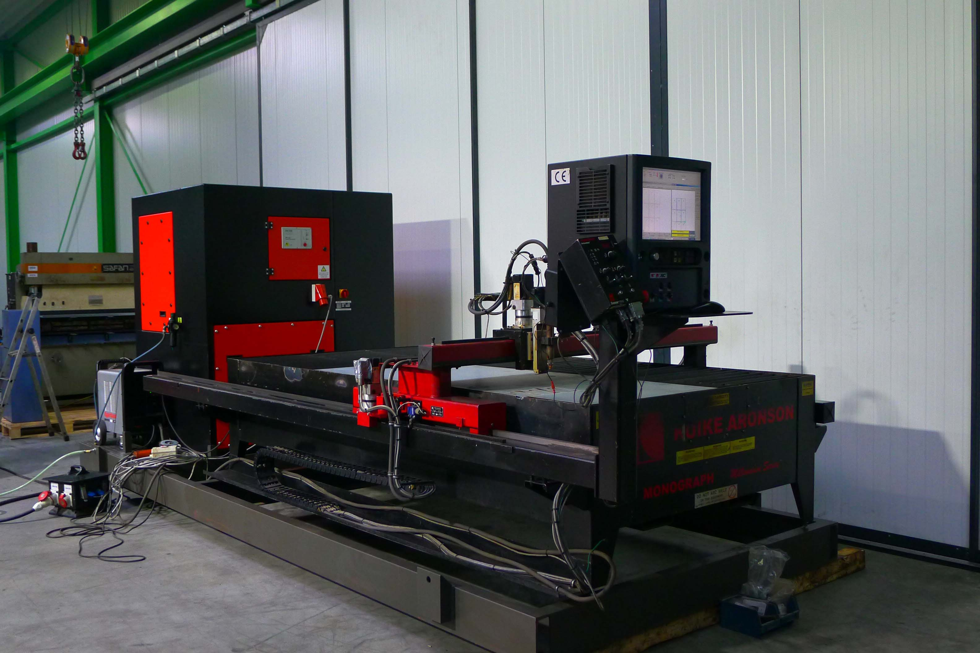

- Make : KOIKE Aronson
- Typ : Monograph Millenium
- Age : 07 / 2008
- Mach.No. : 231260

- Working area
- X : 3.000
- Y : 1.500
- Capacity : 15 mm
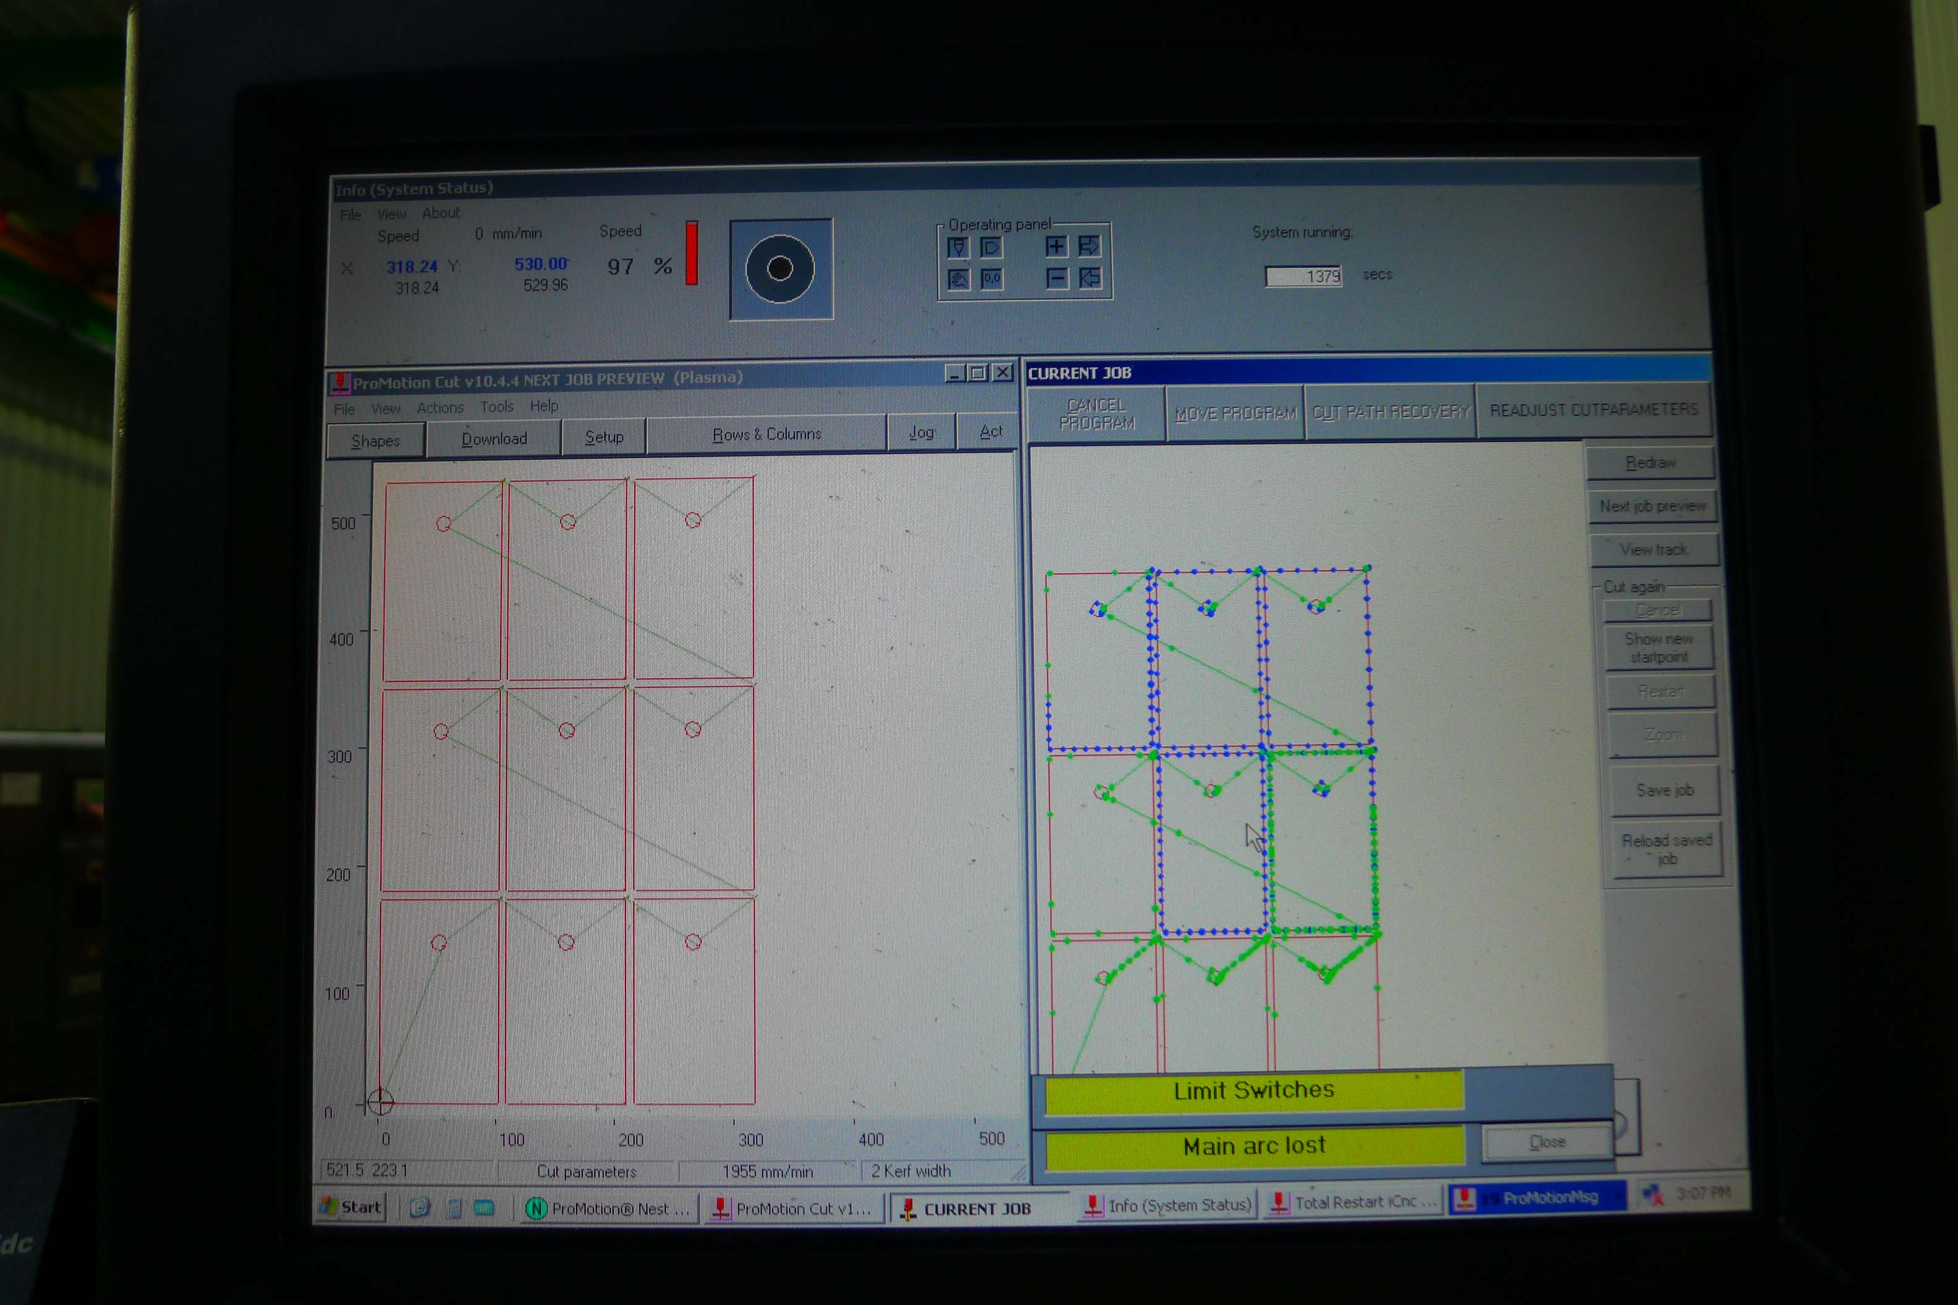

- Length : 5.000
- Width : 2.140
- Height : 1.600

- Accuracy : 0.05 mm
- Working speed : 1.400 mm/Min

- Hypertherm POWERMAX 1650
- Cutting up to 0.6 – 15 mm
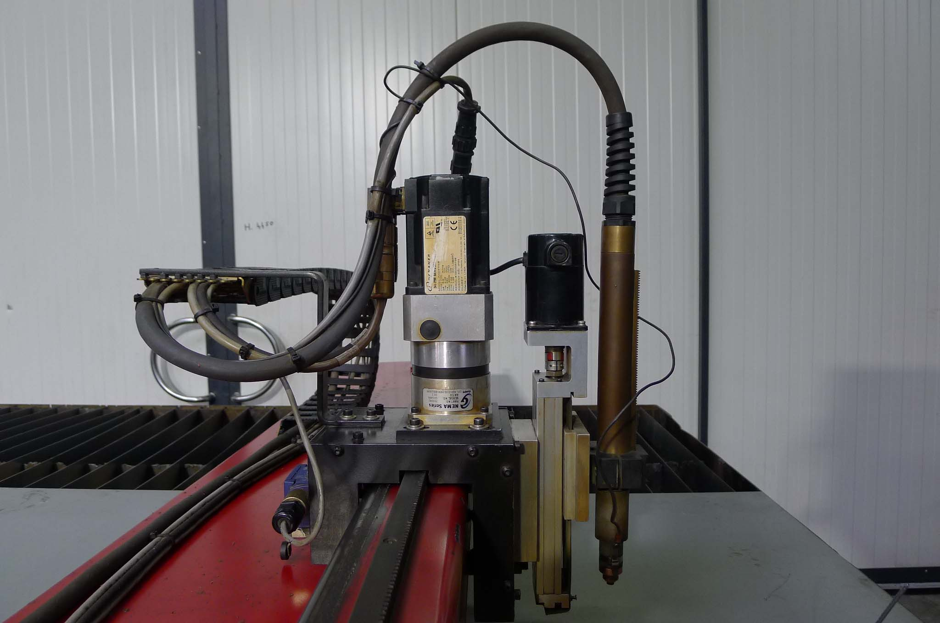
- Amp 30 – 100
- Capacity 32 – 500 mm/min

- KAR Koike CNC Promotion
- DXF conversion
- Network / USB / RS232

- Filtration Van Dijk’s Nederland
- 3800 M³
- Voorzien van 4 Patronen

Please Note: The above information has been obtained to the best of our ability and belief from, and from the manufacturers where possible. It is given in good faith, but its accuracy can not be guaranteed. Accordingly, it will not form a representation or constitute contractual terms. We advise you to check any vital details!

